Regular Paper, Note, Rapid Communication, Review
(Surrounds one by a circle.)

[Title]
Latent Image Analysis of Positive Charging-Type Single Layered Organic Photoreceptor
(in the headline capitalization style: capitalize each word with four or more letters)

[Authors’ names]
Koji TANAKA,¹ Taro GAZO,² and Hanako FUJIYAMA*²

Notes: Surname (family name) should be written in capital letters. In multiple authors, the authors’ affiliations should be indicated by numerical superscript (¹, ², ³, …). In case of single-authored paper or all authors are in the same affiliation, the numerical superscript is not necessary.
The corresponding author should be marked by an asterisk (*) even in case of single-authored paper.

[Authors’ affiliations] The affiliations listed below will be printed in the manuscript's first page.
¹ Xxxxxxx Center, Xxxxx INC.
16-1, xxxxxx xxxxxxx xxxxxxxx 123-4567, Japan

² Xxxxxxx Group, Xxxxx Co., Ltd.
15-2, xxxxxx xxxxxxx xxxxxxxx 234-5678, Japan

[Contact information]
Prior to the publication of the Journal of the Imaging Society of Japan, the printing company will send a proof of the manuscript to the author for final confirmation. Please provide the contact information of the representative author who will carry out the final confirmation below.

(Contact information of representative author)
Name:
Affiliation:
Addresses:
Phone number:
Fax number:
E-mail address:
[Abstract] (100–150 words)
In the current consumer market of the xxxxx ****************************************
The image was printed on PET (polyethylene terephthalate) film at 600 dpi (dots per inch). ****************************************************************************************************************************************************************************************************************************************************.
NOTE: Abbreviations and acronyms should be explained on the first appearance. The full name should be given in brackets. As a rule, lower case letters are used, but proper nouns should be capitalized at the beginning.

[Keywords] Around five words
Please indicate four to five keywords or phrases in alphabetical order, separated by commas.

Inkjet，Long-distance printing，******, ******, ******

(With the first word of each term capitalized.)

(From here, please provide the main body of the article.)
The number of words on a single page in the Journal is approximately 1000. Figures and tables will be inserted in the texts. A figure or a table is equivalent from 140 to 280 words.
The numbers of pages of the articles are as follows: Original Paper is limited within 10 pages, Note is within two pages, and Rapid Communication is within four pages. Tutorial Review, Review, and Technical Information are not limited, but are supposed to follows Original Paper.
For example, an article with eight pages corresponds to approximately 8000 words (8*1000 words). If the article includes 10 figures and/or tables, it equivalently corresponds 210*10 = 2100 words. Therefore, the actual required number of words of the articles is 8000 - 2100 = 5900 words.

1. Introduction (chapters and sections: capitalize each word with four or more letters)
***********. AAA properties of BBBB are shown in Fig. 1. (Refer each figure as “Fig.1” etc. in the text.)****************************************************************************. Figure 2 shows CCCC spectra of DDDD. (When "Fig." is placed at the beginning of a sentence, it should be written as "Figure.") ***************************************************** ***********************************************************************************************************************************************************.

2. Expertiment
******************************************************************************
**************************************************************************************************************************************************************************************************************************************************.¹⁾

2.1 Apparatuses and Equipment
*******************************************************************************.
The images were printed on PET (polyethylene terephthalate) film at a resolution of 600 dpi (dots per inch). ***************************************************************************** **********************************************************************************************************************************************************.^{2,3)}
NOTE: Abbreviations and acronyms should also be explained on the first appearance in the text.

2.2 Measurements of Imaging Properties
*******************************************************************************
*************************************.⁴⁻⁶⁾ *****************************************
**************************************************************************************************************************************************************.⁷⁻¹³⁾

2.3 ****************
********************************************************************************.
***************************** *****************************************************************************************************************************************************************.

2.4 ****************
*************************************************************. ******************. The relative luminescence intensity at 10 s was measured to be 2.5 × 10⁻² arb. unit. ************* *****************************************************************************************************************************************************************.
NOTE: Physical quantities, units, and symbols should be in accordance with the IUPAC Green Book, which can be downloaded from the IUPAC website and the Japanese translation from the website of the National Metrology Institute of Japan, National Institute of Advanced Industrial Science and Technology. The following are examples of units that can easily be misinterpreted.
Unit Symbol NG
second s sec, sec.
degree °, deg deg. (with period)
arbitrary unit arb. unit a.u.

3. Result and Discussion
******************************************************************************
****************************************************************************************************************************************************************************************************************************************************．

3.1 ****************
******************************************************************************
****************************************************************************************************************************************************************************************************************************************************.

3.2 ****************
******************************************************************************
****************************************************************************************************************************************************************************************************************************************************.

NOTE: Symbols representing physical quantities should be written in italics. Subscripts, in principle, should be written in Roman type. Subscripts for physical quantities and variables should be italicized. The following are examples.
Applied voltage V_{in} (“V” in italics, “in” in Roman type)
Constant pressure heat capacity C_{p} (“C” in italics, “p” in italics)
Partial pressure of the i-th substance P_{i} (“P” in italics, “i” in italics)

4. Conclusion
******************************************************************************
****************************************************************************************************************************************************************************************************************************************************.

[References]
All bibliographical references should be numbered and listed at the end of the text. The key points to describe the references and typical examples of the references are shown below. It is detailed in Chapter 4 of “writing guideline” (in Japanese) for submitting to the Journal of imaging society of Japan.
＜Key points＞
(a) The sentence capitalization style is, as a rule, a style in which only the first letter of the first word is capitalized. Title of “articles” published in scientific journals, electronic journals, preprints, and conference proceedings conform to this style of writing. Names of patents, standards, and website documents also conform to this style.
(b) The headline capitalization style is, as a rule, a style in which the first letter of each word with four or more letters is capitalized. Journal names, book names, and conference names conform to this style.
(c) Separate each bibliographical element [e.g., author name, article name, journal name, volume number, reference pages, published date, DOI (digital object identifier), etc.] with a comma and a space, and add a period at the end of the bibliographical element. The information (e.g., internet address, accessed date, etc.) of URL (uniform resource locator) is note item. Please write a space after the period at the end of the bibliographical element, and write the note item such as “URL, (accessed YYYY-MM-DD).”
(d) If a doi is available, please list the doi. Both styles, DOI with "doi:" prefix and URL with DOI, can be used, but the style should be the same in the paper.
(e) All authors should be listed. Authors' names should be listed in the order of first name, middle name, and family name. First and middle names should be written using initials and a period. Insert a space after a period.
(f) Name of the journals, books, conference proceedings, patents, standards, and website documents should not be abbreviated. The full name should be given.
(g) In the case of Japanese literature, please add [in Japanese] at the end of the bibliographical element. For bibliographical elements that do not have an official English name, please write them in Hepburn romanization spelling.
- Scientific journals and research reports
Authors, “title of the article,” journal name, volume in bold (issue number), pp. start page-end page (published year). [in language (if needed)]. DOI (if available).
(e.g.) K. Nakajima, “Current bubble jet technology,” Journal of the Imaging Society of Japan, 41, pp. 159-166 (2002), doi:10.11370/isj.41.159［in Japanese].

- Electronic journals
Authors, “title of the article,” journal name, volume in bold (issue number), pp. start page-end page (year), DOI (if available). URL, (accessed date, only if URL is listed).
(e.g.) S. A. Mabon, T. Misteli, “Differential recruitment of pre-mRNA splicing factors to alternatively spliced transcripts in vivo,” PLOS Biology, 3, e374, p. 1 (2005). doi:10.1371/journal.pbio.0030374. https://journals.plos.org/plosbiology/article?id=10.1371/ journal.pbio.0030374, (accessed 2019-06-26).
- Preprints
Authors, “title of the preprint paper,” name of the publisher or server, preprint number, pp. start page-end page (year), DOI. URL (accessed date).
(e.g.) Y. Suenaga, T. Nagase, and H. Naito, “Interpretation of the modulus spectra of organic field-effect transistors with electrode overlap and peripheral regions: Determination of the electronic properties of the gate insulator and organic semiconductor,” arXiv.org, 2001.03957, pp. 1-16 (2020). https://arxiv.org/abs/2001.03957, (accessed 2020-09-23).
- Books
Authors/editors, “name of the book,” the number of editions, publisher (year), the total pages p., ISBN.
(e.g.) R. M. Schaffert, “Electrophotography,” Second Edition, Focal Press (1975), 989 p., ISBN 9780240507811.
- Scientific conference proceedings (collection papers)
Authors, “title of the presentation paper,” proceedings of the conference (abbreviated conference name), organizer of the conference (year), presentation number, pp. start page-end page.
(e.g.) Y. Harada, “Measurement of viscosity process of ink droplets landed on media,” Proceedings of the 123rd Annual Conference of the Imaging Society of Japan (Imaging Conference Japan 2019), IJ2-03, pp. 39-42 [in Japanese].
- Patents
Applicant names, “title of the patent,” country of the patent application, the patent number, (published year or registered year), the total number of pages p.
(e.g.) W. J. Nowak, J. A. Alvarez, R. A. Clark, M. F. Zona, C. Liu, and P. J. McConville (Xerox Corporation), “Electrostatic 3-D printer controlling layer topography using aerosol applicator,” United States Patent Application Publication, US 2018-0361661 A1 (2018), 36 p.
- Standards
Standard number: published year, “title of the standard,” publisher, the total number of pages p.
(e.g.) JIS Z 9095: 2011, “Graphical symbols--safety signs--safety way guidance systems (SWGS)- Phosphorescence type,” Japanese Standards Association, 36 p. [in Japanese].
- Web sites
Publisher name, “title of the webpage.” URL, (accessed YYYY-MM-DD).
(e.g.) The Imaging Society of Japan, “How to post to the Journal of the Imaging Society of Japan.” http://www.isj-imaging.org/ISJ_journal/e-submission(e).html, (accessed 2020-05-10).
[Figure captions and table captions]

- Figure captions (titles and descriptions) should be provided at the end of the main body.

Example: Fig. 1 Toner image transfer model.
Fig. 2 Relationship between transfer ratio and transferred charge density on transfer material.
Fig. 3 Cross-sectional view of laser printer.

- Table captions (titles and descriptions) should be also provided at the end of the main body.

Example: Table 1 Optimum toner charge-to-mass ratio.
Table 2 Optimum toner charge-to-mass ratio for three kinds of photoconductors.

[Personal biographies of Author (s)]
Koji TANAKA
He received the B.Sc. and M.E. degrees from XXXX University in 1982 and 1984, respectively.
In 1985, he joined XXXX Company. Since then, he has researched and developed electrophotography process.

Taro GAZO
.........

Hanako FUJIYAMA
.........

[Portrait(s)]
Please embed a digital data of the portrait(s) of the Author(s).

Koji TANAKA
Photo

Taro GAZO
.........

Hanako FUJIYAMA
.........

Instruction for the figures
- According to the following instruction, provide appropriate figures. Captions are not required, otherwise the figure number must be written as “Fig. 1” in each figure. Only one figure must be appeared in one page (to prevent from degradation in printing, make figures in higher resolution as possible). The file in the jpg, tiff, or pdf format is desirable. Fig. 1 and Fig. 2 are the sample figures.
- In the printed journal, the manuscripts will be printed in black and white, except in cases where the use of color will enhance understanding. Therefore, when using colors in the figures and tables, please take into account the ability to differentiate by brightness rather than by hue. In the web version, the color figures are available for free of charge.

[Instructions]
1) Use English (American usage and spelling) in figures.
2) Refer each figure as Fig.1 etc. in the text. If the figure includes multiple parts, please indicate each part of the figure as Fig. 1(a), Fig. 1(b), etc. When "Fig." is placed at the beginning of a sentence, it should be written as "Figure."
3) Captions should follow the "sentence capitalization style;" i.e., the first letter of the terms or sentences in the figure must be capitalized. (e.g., Transfer roller, etc.)
4) Add a period at the end of figure caption. (e.g., Fig.1 Toner image transfer model.)
5) The horizontal and vertical axes should have 4 to 5 scales.
6) The vertical and horizontal axis labels should have a physical quantity symbol following the physical quantity name, with the unit symbol in parentheses. It is acceptable to use the notation presented with the ratio of the physical quantity symbol to the unit symbol, which is recommended by the International System of unite (SI)，or the notation presented with the ratio added with the physical quantity names. Put spaces before and after the slash. These notation systems should be consistent throughout the paper.
Good example: “Surface resistivity R (10⁸ Ω cm),”
“M / A m⁻¹,” “Magnetization, M / A m⁻¹”
Bad example: “M”, “Magnetization/ (A m⁻¹)”
7) See Fig. 2 (a), an example of a well-prepared line drawing, and Fig. 2 (b), a poorly prepared drawing.
i) Boundary lines or outlines are not required.
ii) Outer lines surrounding legends are not required.
iii) Locate the legend in the area which composed of vertical axis, horizontal axis and opposite two axes.
iv) Axis lines must be drawn thinner than data lines.
8) Describe the number representing the power using superscript such as 10¹².
9) A space must be provided between the number and the unit symbol. (e.g., 10 mm, 10 kg, 95 %, 45 °C, etc.)
10) The use of an italic and Roman type conforms to the IUPAC rule.
Overall rule: Symbols representing physical quantities (or variables) are written in italics, but symbols representing units and descriptive terms (such as a label) are Roman.
Additional character with superscripts/subscripts: Overall rule above is adaptable for the superscripts/subscripts attached to physical quantity symbols or mathematical variables. Basically, superscripts/subscripts should be in Roman. Unit symbols are also in Roman. However, subscripts representing physical quantities or variables such as ordinal numbers (called ”running number”) must be written in italics.
(e.g.) Applied voltage V_{in} (quantity symbol: italic, subscript: Roman), Constant pressure heat capacity C_{p} (quantity symbol: italic, subscript: italic to represent physical quantity), Partial pressure P_{i} of the i-th substance (quantity symbol: italic, subscript: italic because it indicates the ordinal number), 5 mm (unit symbol: Roman)
11) Symbols for a variable vector quantity must be written in bold and italic style.
12) In general, n (nano), m (milli), k (kilo), etc. which represent the power of the number are written in lowercase except for T (tera), G (giga), etc.
13) The unit symbol must be written correctively including uppercase and lowercase letters, in accordance with the JIS Z8000 standard group regulations specified by the International System of Units (SI). It is detailed in section 2.8 of “Writing Guideline” for submitting to the journal of Imaging Society of Japan (in Japanese). The following unit symbols are frequently mistaken. For example, “s”（not “sec” or “sec.”）indicates seconds, “deg” indicates angles (“degree” is the unit name; the “deg.” symbol which is an abbreviation for degrees cannot be used as unit symbol) , and “arbitrary unit” is abbreviated as “arb. unit” (“a.u.” cannot be used, because it is confused with atomic unit or astronomical unit).
14) Description of the physical quantity name (i.e., parameter name), the physical quantity symbol for parameter name, and unit symbol is as follows: “Surface resistivity R (Ω cm)”.
15) Only the first letter of the first word in a term is capitalized in case the term includes multiple words.

Fig. 1
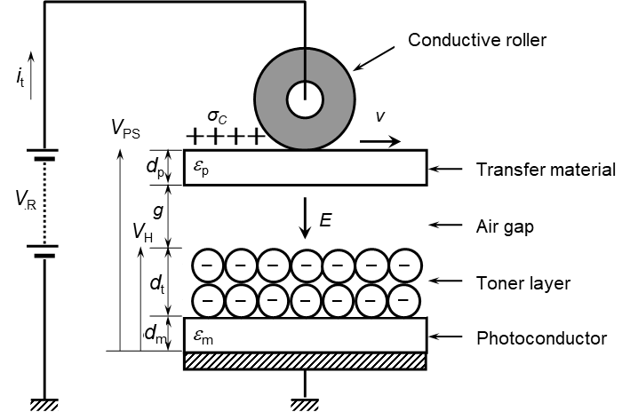

Fig. 2
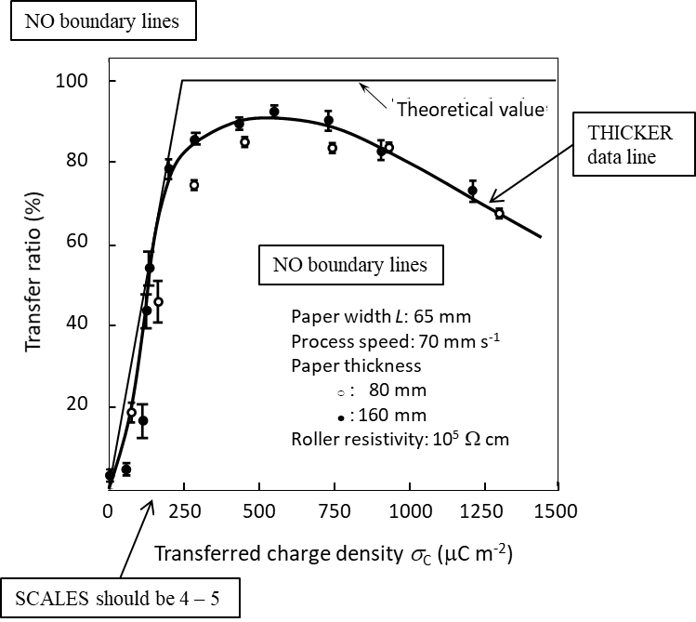
(a) Well-prepared drawing

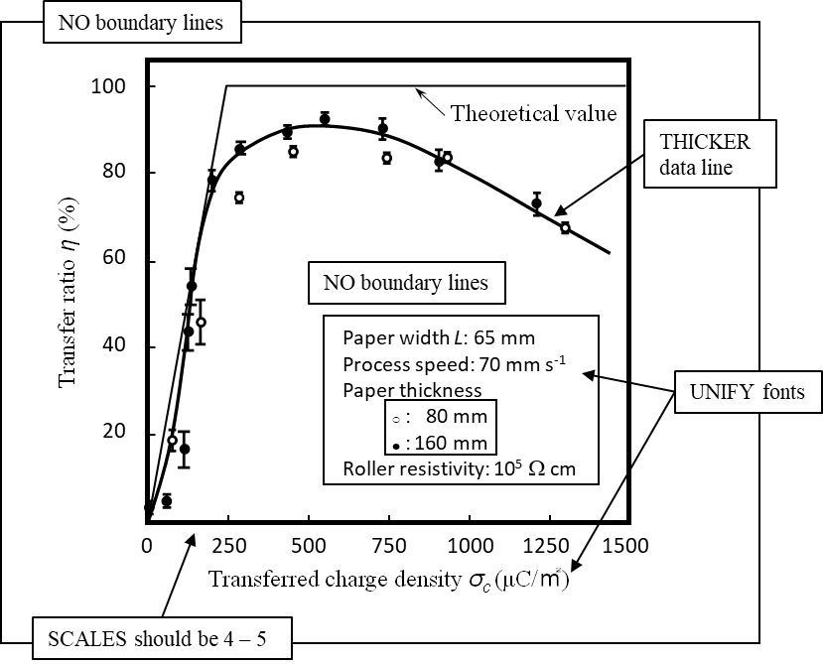
(b) Poorly prepared drawing
Instruction for the tables
- According to the following instruction, provide appropriate tables. Captions are not required, otherwise the figure number must be written as “Table 1” in each figure. Only one figure must be appeared in one page (to prevent from degradation in printing, make figures in higher resolution as possible). The file in the jpg, tiff, or pdf format is desirable. Table 1 is the sample figures.
- In the printed journal, the manuscripts will be printed in black and white, except in cases where the use of color will enhance understanding. Therefore, when using colors in the figures and tables, please take into account the ability to differentiate by brightness rather than by hue. In the web version, the color figures are available for free of charge.

[Instructions]
1) Use English (American usage and spelling) in tables.
2) Refer each table as Table1 etc. in the text.
3) Captions should follow the "sentence capitalization style;" i.e., the first letter of the terms or sentences in the table must be capitalized. (e.g., Charge-to-mass ratio)
4) Add a period at the end of table caption. (e.g., Table 1 Toner image transfer model.)
5) See Table 1, an example of a well-prepared table.
i) Boundary lines or outlines are not required.
ii) Vertical lines are not required.
III) Only essential horizontal lines should be listed.
6) For other items, follow the “Instruction for figures.” Replace “figure” with “table.”

Table 1

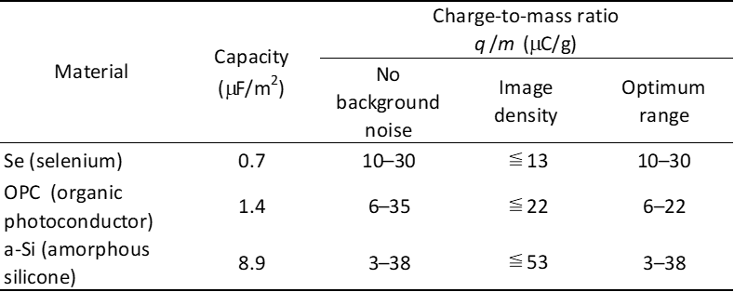

Pre-Submission Checklist

Before submitting your manuscript to the Journal of the Imaging Society of Japan, please use this checklist to check the key points as below. After checking, please submit this checklist together with the manuscript.

1. Before submitting a manuscript:
( ) The title of the paper, the names of the authors including co-authors and their affiliations are given.
( ) Titles of the paper, chapter, section are given in the headline capitalization style.
( ) Abbreviations and acronyms should also be explained on the first appearance both in the abstract and the text.
( ) Physical quantities, units, and symbols conform to IUPAC rule.
( ) Arbitrary unit, degree, and second should be abbreviated as “arb. unit,” “deg” or “°,” and “s.” “a.u.,” “deg.,” or “sec.” should not be used.
( ) Physical quantities and variables are given in italics.
( ) Notations with units preceding the % (e.g., X wt%, Y v/v%, etc.) should not be given; use 'weight fraction X%', 'volume fraction Y%,' etc., or define at first appearance as "wt% denotes weight fraction."
( ) Symbols representing physical quantities should be written in italics. Subscripts, in principle, should be written in Roman type. Subscripts for physical quantities and variables should be italicized, e.g., applied voltage V_{in}, constant pressure heat capacity C_{p}, partial pressure of the i-th substance P_{i}
( ) Annotations to product names are appended (e.g., at the end of the text).
( ) Figures, tables and formulae are correctly cited.
( ) When "Fig." is placed at the beginning of a sentence, it should be written as "Figure."
( ) Superscript number with “)” when citing references as ¹⁾, ^{2,3)}, ⁴⁻⁶⁾, ^{7,8,9-12)}
( ) The citation of references conforms to the format of the writing guidelines.
( ) The sentence capitalization style and the headline capitalization style are used according to the writing guidelines.
( ) The last author should connect with “and” (for two authors) or “, and” (for three or more authors).
( ) The ISBN should be given for citing a book with only a Japanese title.
( ) If an article, journal, book, or webpage has a title in Japanese only, the title should be given in Hepburnian Roman spelling. English translation can be given in brackets [ ] after the Romanized title.

2. Before submitting a revised manuscript:
( ) Submit a revised manuscript file and a response file with responses to the reviewers' remarks.

3. Before submitting a proof manuscript:
( ) Write the corrections in red on the proof manuscript, convert it to pdf and submit it.

